**Course Methods Year 12 test two 2022**

Student name: ________________ Teacher name: ________________

**Task type: Response**

**Time allowed for this task: _____40______ mins**

**Number of questions: ____7_______**

**Materials required: Upto 3 calculators/classpads allowed**

Standard items: Pens (blue/black preferred), pencils (including coloured), sharpener, correction fluid/tape, eraser, ruler, highlighters

Special items: Drawing instruments, templates, **one page of A4 notes doublesided**

**Marks available: ___40___ marks**

**Task weighting: _10___%**

**Formula sheet provided: Yes**

**Note: All part questions worth more than 2 marks require working to obtain full marks.**

Q1 (2 & 2 = 4 marks) (3.2.1)

Let ,

1. Determine an expression for the rate of change of .
2. Determine  given that .

Q2 (3 marks) (3.2.3-3.2.9)

Determine  in terms of  given that  and  when .

Q3 (4 marks) (3.2.21-3.2.22)

A particle travels along a straight line such that its acceleration at time  seconds is equal to . When  the displacement is 10 metres and when  the displacement is 20 metres. Determine the displacement when .

Q4 (6 marks) (3.2.19-3.2.20)

Make a sketch showing the graphs of  and  indicating clearly on your sketch the coordinates (2 dp) of any stationary points, inflection (if any) and of any points where the functions intersect each other.

Determine the area between the graphs to 2 dp.

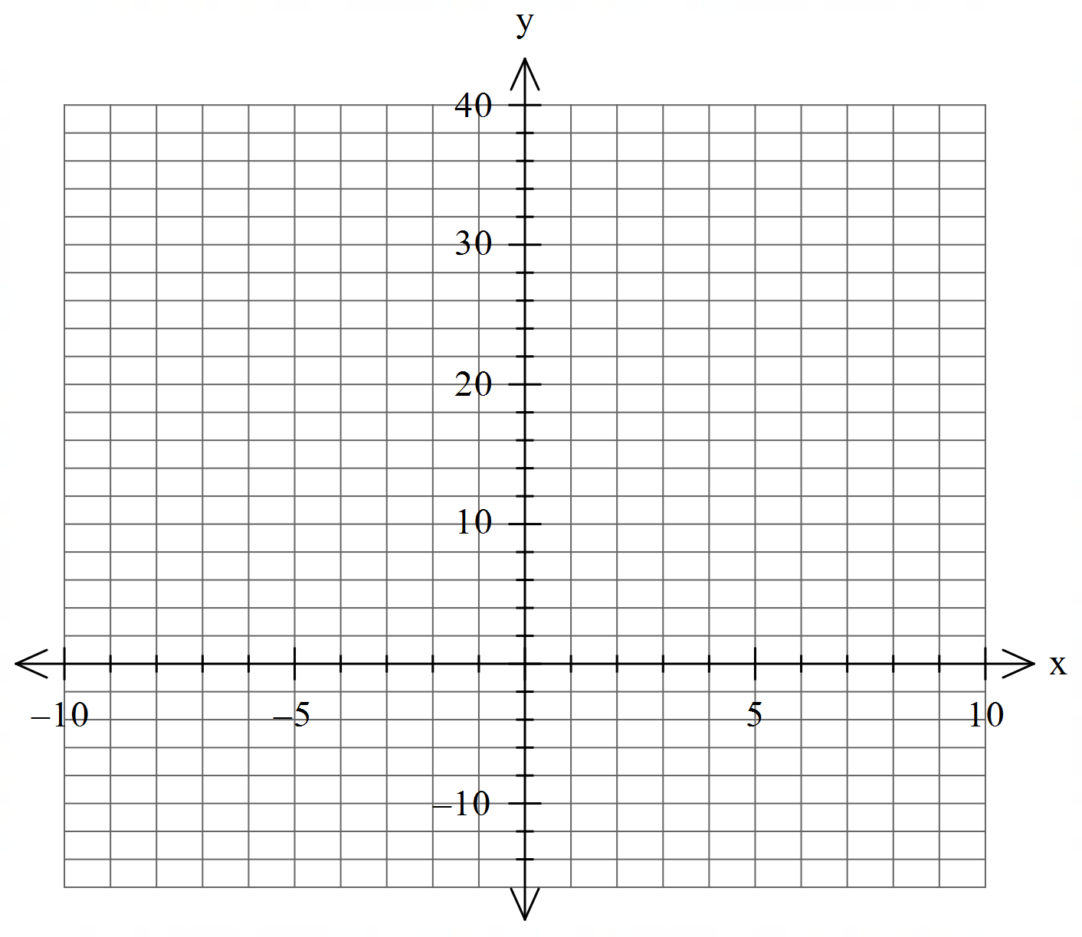

Q5 (4 & 3 = 7 marks) (3.1.2-3.1.3)

Let 

1. Using **calculus** determine all stationary points and their nature. Justify.
2. Determine the x values of any inflection points.

Q6 (2, 2, 2 & 2 = 8 marks) (3.2.15-3.2.17)

Consider the function  which is graphed below.

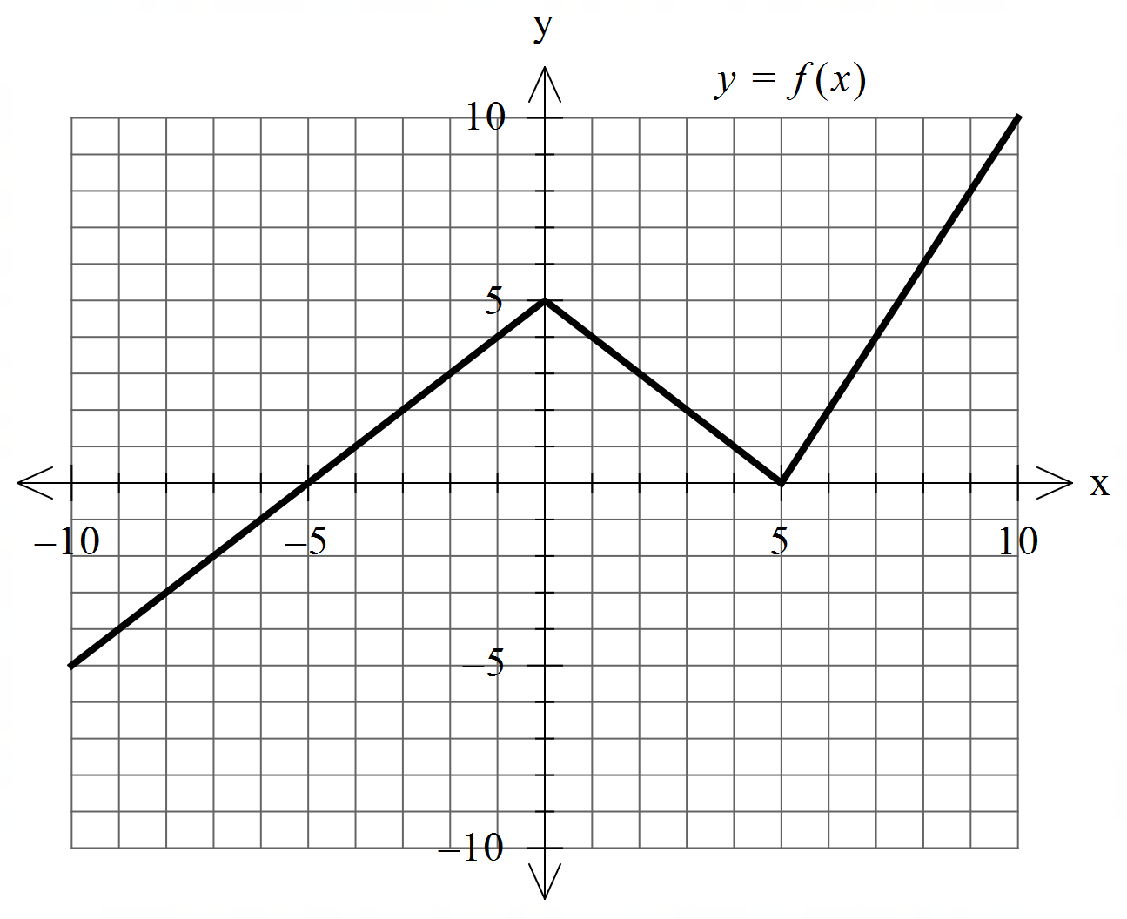

Determine the following.

1. .
2. .
3.  when .
4. The area enclosed between  and the line .

Q7 (1, 3 & 4 = 8 marks) (3.2.5-3.1.6)

The cross section of a mountain can be given by  for  metres where  = height at  metres.

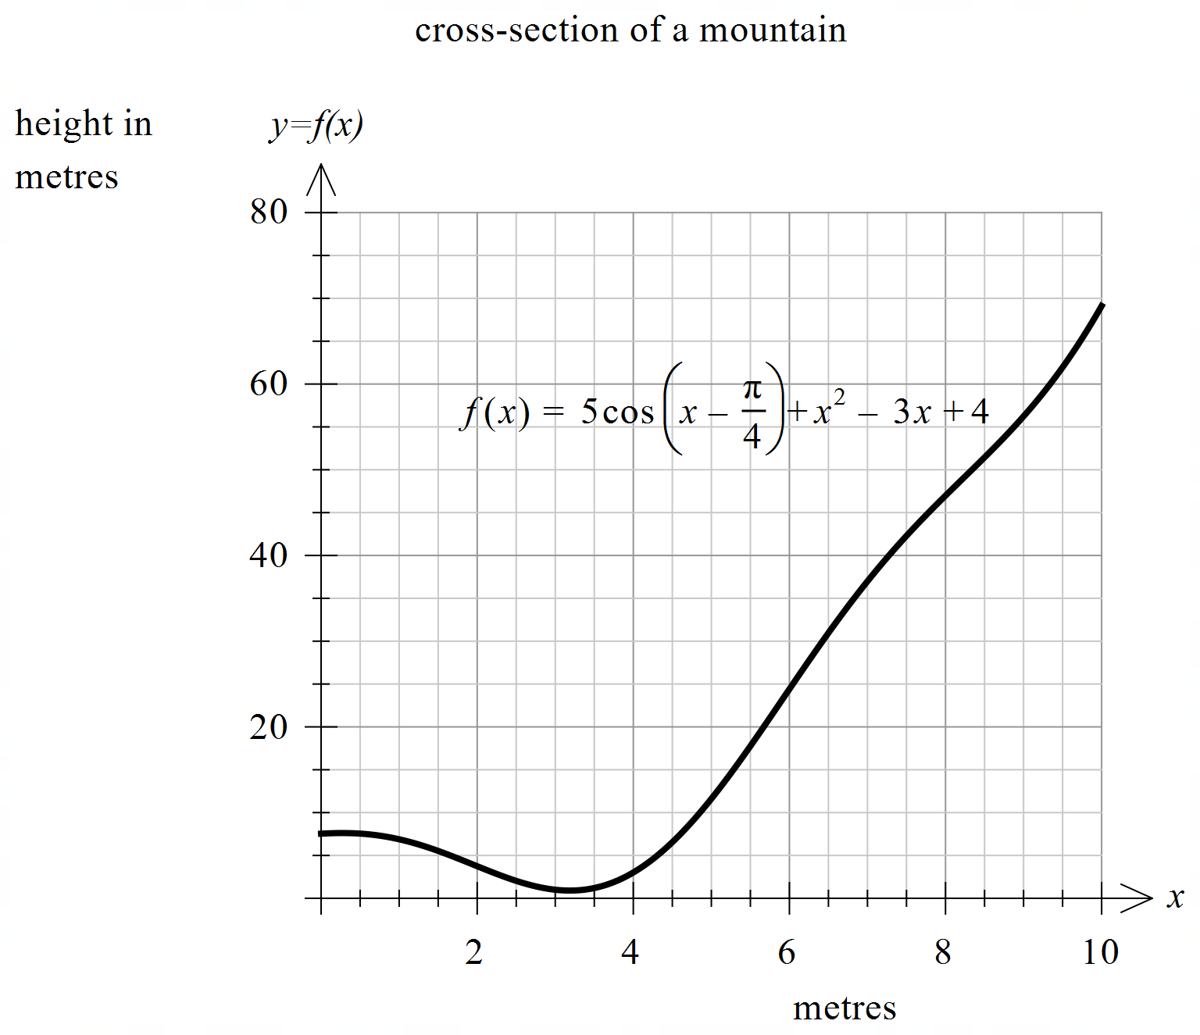

1. Determine .
2. Determine the minimum height of the mountain to 2 decimal places. Justify.

Q7 continued

1. A water collection tank will be placed at the **steepest** part of the mountain. Determine the coordinates of this point to 2 decimal places. Justify.

Extra working space